## TRAFFIC MANAGEMENT(IOT)

# NAME : A.Suji

# ID:aut962921104711

# Email:suji76531@gmail.com

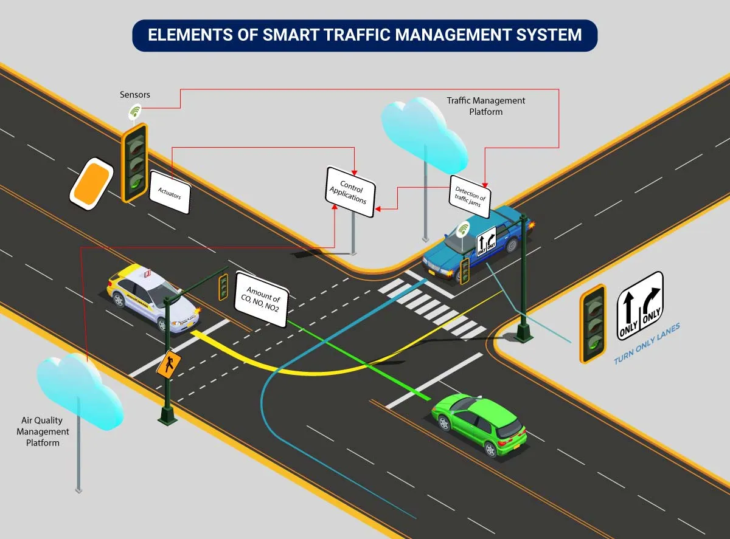

## 

## TABLE OF CONTENT

I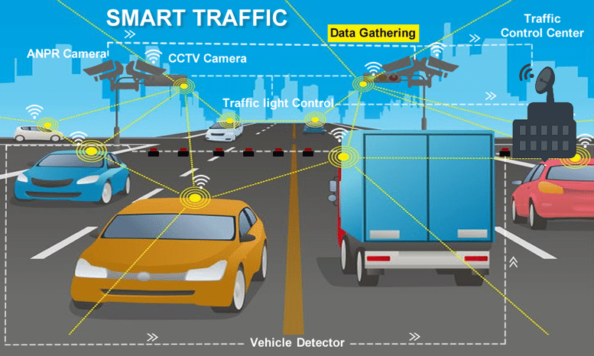

Innovation………………………………..3

User understanding…………………..6

Conclusion………………………………..7

## 

## INNOVATION:

These innovative solutions are used alongside traditional methods and give city officials new insights into how to make roadways more efficient and sustainable. Let’s take a look at a few of these technologies shaping our future.

Real-Time Traffic Feedback

Cities across the United States have started utilizing Internet of Things (IoT)-enabled sensors. These sensors are placed on roads and public transit routes and allow anyone to go online to view levels of traffic congestion, available parking spaces, and locations of busses and streetcars. The Kansas City streetcar system’s IoT sensors have helped revitalize the public transit system as citizens know exactly where the streetcars are and how long before they reach pickup locations.

Adaptive Traffic Signals

Vehicle to Infrastructure (V2I) technology lets automobiles “communicate” with adaptive traffic control signals to help cities gain better insights into traffic patterns and problems.

Cities are outfitting government vehicles with V2I devices that relay information about individual cars’ speeds, movements, time spent at lights, and other valuable data.This information is giving officials insight into how long vehicles sit at idle lights, so they can improve signal timing to make drive times more sustainable and efficient.

V2I Safety Signals

While some states’ drivers deal with frequent roadway congestion, others have to worry about inclement weather. States like Wyoming have started using V2I to relay information about hazardous weather and other obstructions to drivers statewide. The Wyoming Department of Transit’s Connected Vehicle Pilot Program has 75 short-range communication units installed at critical points along their major highways, with sensors equipped in government snowplows, patrol cruisers, and trucks. These vehicles and sensors then relay information about road conditions to drivers using radio, cellular, and fiber connections to improve.

Pedestrian Tracking Systems

V2I technologies can also be used to improve safety for pedestrians. Some cities such as Las Vegas use V2I and vision-based data to detect vehicle and pedestrian behavior at intersections. By tracking how many cars and pedestrians pass through an intersection, city planners can determine how to shift traffic flows and when to time traffic light changes. This increases roadway efficiency and makes intersections safer to cross for pedestrians.

# Madurai city to have intelligent traffic management system soon, ET Government

# How To Determine Traffic Management

A traffic management plan involves planning and controlling the movement of people and goods within an area. This can include stationary and moving traffic, pedestrians, cyclists, and vehicles. The goal of traffic management is to keep this movement orderly and efficiently to minimize risk at the workplace. A traffic management plan is a tool that helps you to do this. A traffic management plan typically includes several elements, such as identifying the types of traffic present, determining the routes they will take, and putting measures to control traffic flow in place. When developing a traffic management plan, it is essential to consider all potential hazards, as even minor problems can cause major disruptions if not properly addressed.

Step1: looking at the floor plan layout and determining where there are overhead structures

Step2: whether work is close to public areas.

Step3: Consider high traffic volumes, which can impact traffic flow and create hazards.

Step4: Check for blind spots, as these can be areas where accidents are more likely to occur.

## User understanding

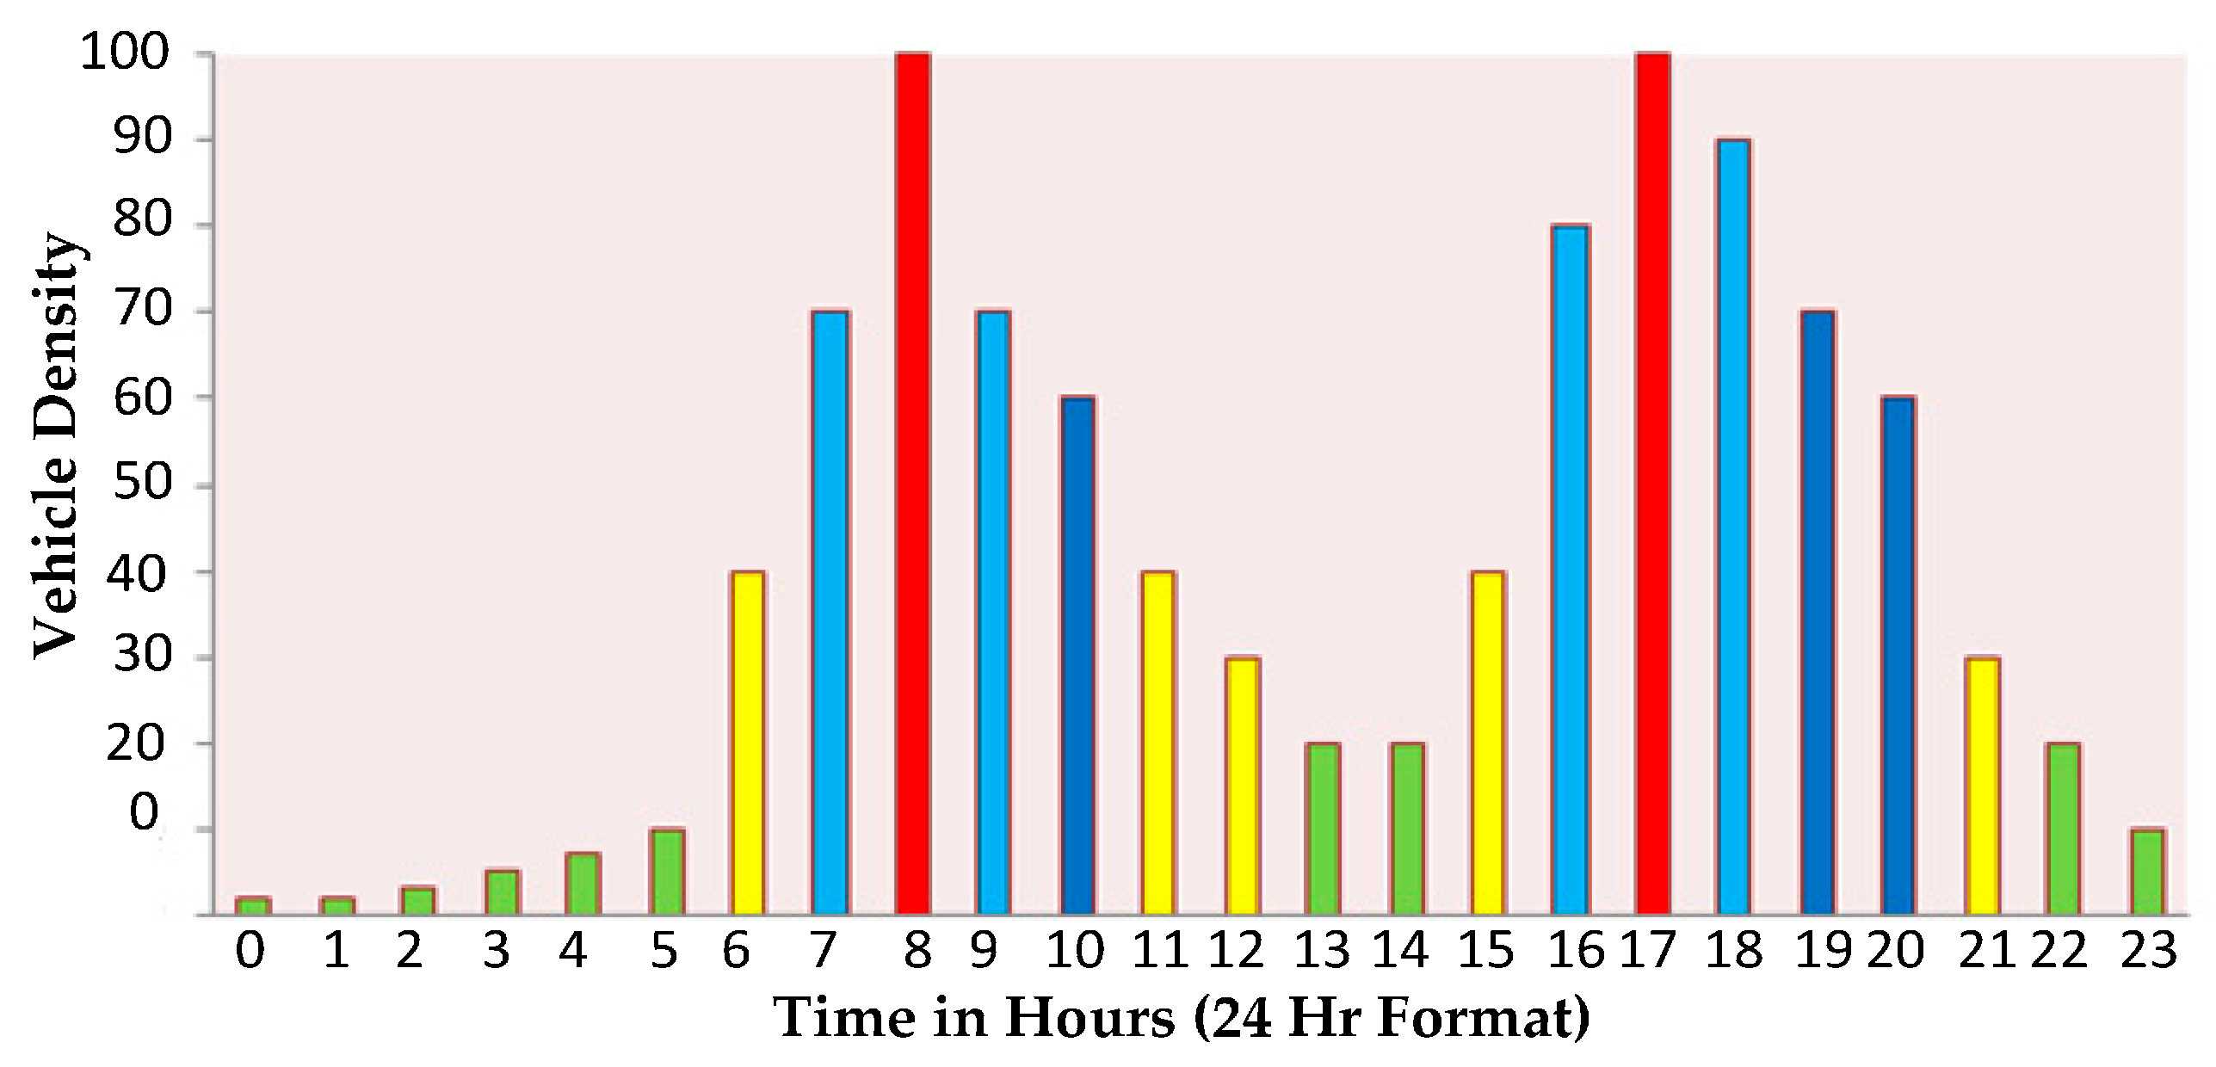

Traffic management measures aim to influence traffic flows over the road network. However, traffic flow consists individual road users travelling from A to B, management aims to influence human behavior . Consequently, the effect of management measure largely depends on the capabilities or motivations of these road users to comply with the measures. If designed and applied without accounting for human factors, effective traffic management measures may not have the intended effect.

Road traffic is ‘the accumulation of road users moving from an origin to a destination along a road network’. So, it is people who make up road traffic; not the vehicles they ride or drive in. Hence, the only way of understanding, predicting and affecting road traffic is by looking at the tasks that a road user undertakes. About thirty years ago, the Dutch professor John Michon developed a basic driving task model3

, which is still a good starting point today for getting a feel for road traffic from a human perspective. The model divides the driving task into three levels: the strategic level, the tactical level and the control level. Traffic management mainly affects the road users’ tasks at the strategic and tactical level.

## Conclusion

Traffic Management refers to the combination of measures that serve to preserve traffic capacity and improve the security, safety and reliability of the overall road transport system. These measures make use of ITS systems, services -to-day operations that impact on road network performance.